using System;
using System.Collections.Generic;
using System.Linq;
using System.Text;

namespace ConsoleApplication1
{
class Program
{
Int x = 0;
void print(int x, int y)
{
x = x = y;
Console.WriteLine(x);

}
static void Main(string[] args)
{
Program p = new Program();
p.print(5,5);
}
}
}

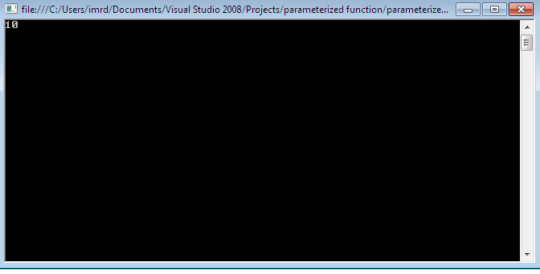
using System;
using System.Collections.Generic;
using System.Linq;
using System.Text;

namespace polymorphism
{
public class Program
{
void add(int a, int b)
{
int c = a + b;
Console.WriteLine("Addition a and b=" + c);
}
void add(int a, int b,int c)
{
int c1 = a + b+c;
Console.WriteLine("Addition a,b and c=" + c1);
}
public static void Main(string[] args)
{
Program p = new Program();
p.add(10, 20);
p.add(10,20,30);
Console.ReadLine();

}
}
}

